

CPP 6101: OBJECT ORIENTED TECHNOLOGIES

GROUP D
ASSIGNMENT 2
MEMBERS:

Robert Mwangi – 25/10289

Marvin Odhiambo – 25/10888

Kiplangat Bruno – 22/06077

George Murithi - 11/03190

Supervisor: Edwin Juma Omol

Github link : https://github.com/Marvo42/Object-Oriented-Technologies

Encapsulation

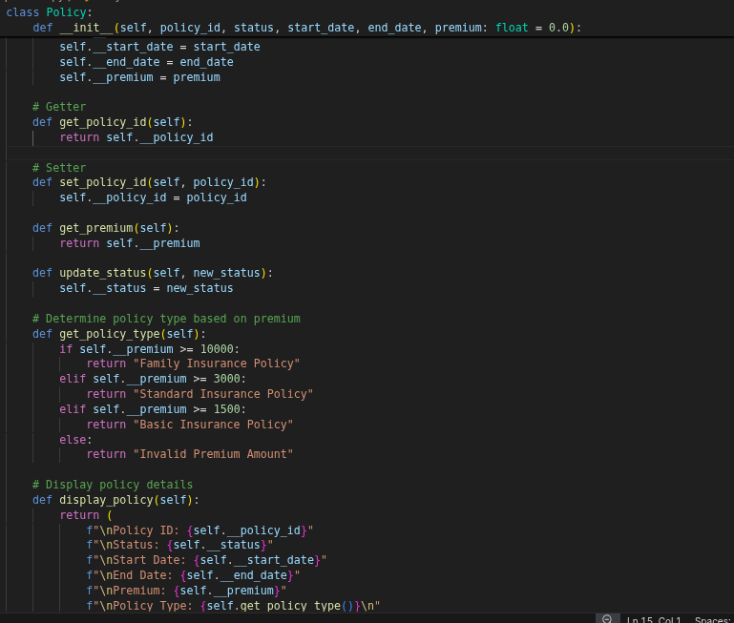

Inheritance & Polymorphism
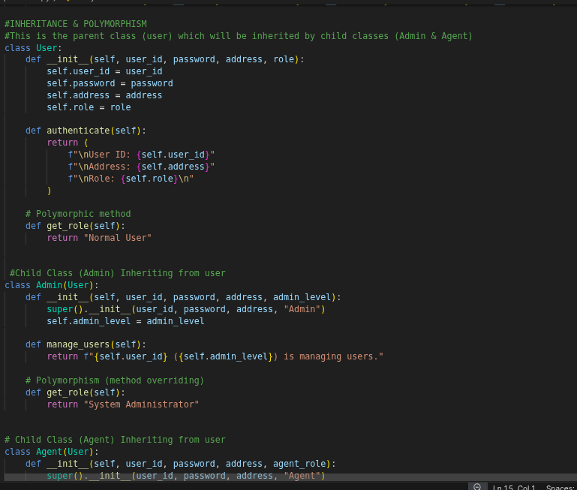

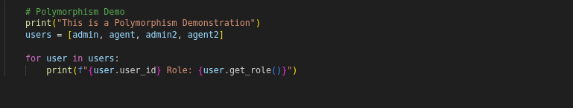
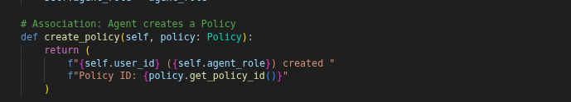
Association
2. Use Case Implementation & Testing

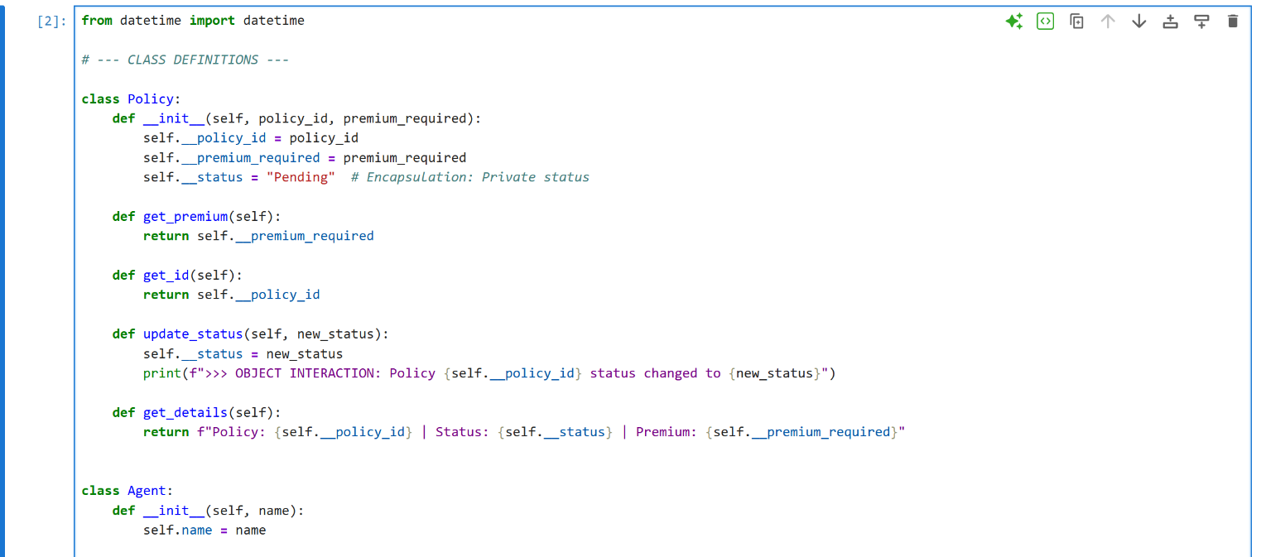

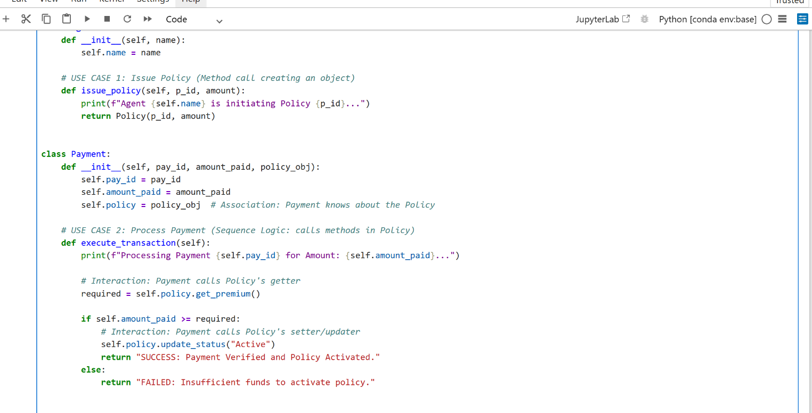

Manual test cases;

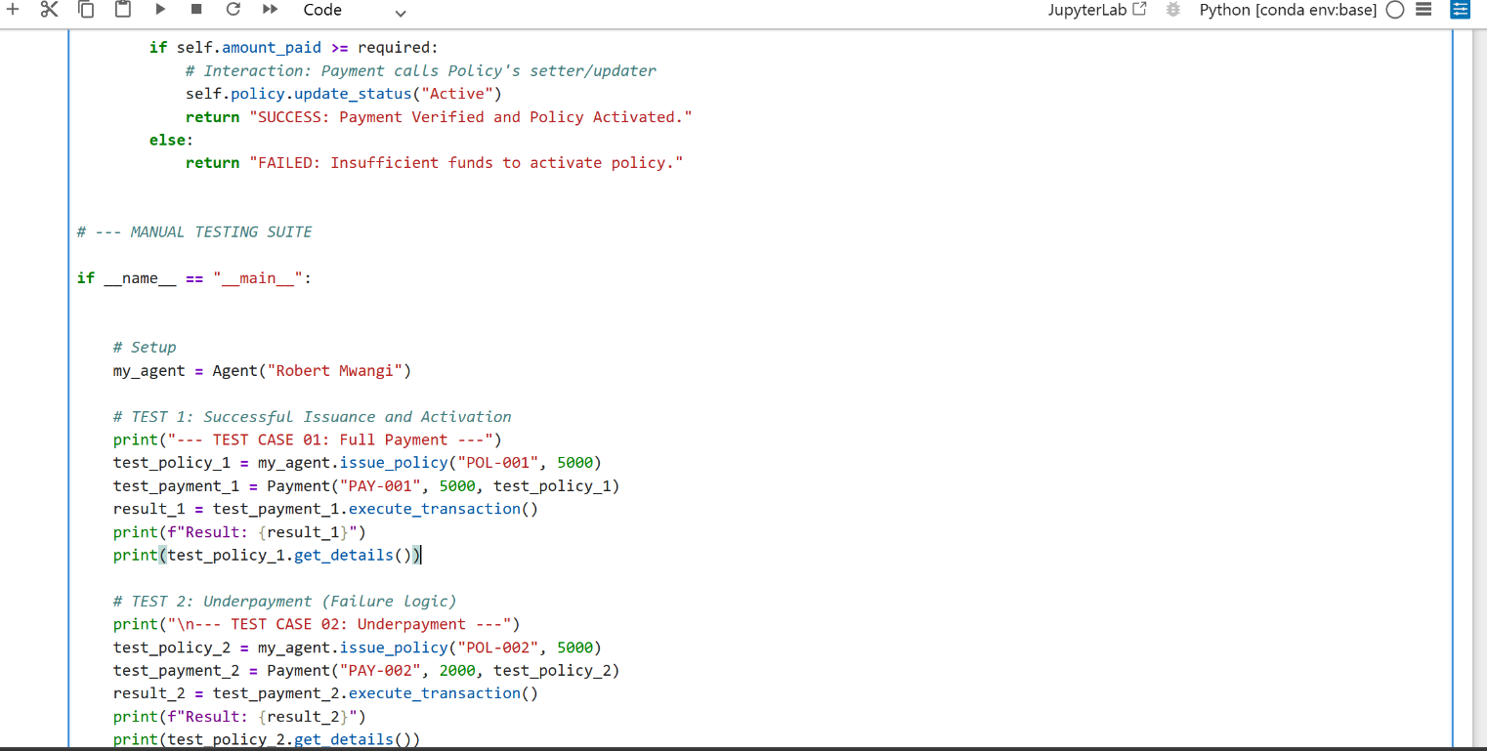

Output;

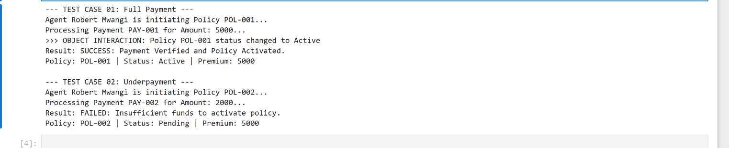

Test Case ID | Use Case | Test Input | Expected Output | Actual Result | Status
TC-01 | Policy Issuance | Agent: Robert Mwangi, ID: POL-001, Premium: 5000 | New Policy object created with "Pending" status | Policy POL-001 initiated by Agent Robert Mwangi | PASS
TC-02 | Full Payment | Payment: PAY-001, Amount: 5000 | System verifies funds; Policy status updates to "Active" | Result: SUCCESS; Status changed to "Active" | PASS
TC-03 | Underpayment | Payment: PAY-002, Amount: 2000 (Required: 5000) | Payment fails; Policy status remains "Pending" | Result: FAILED; Status remained "Pending" | PASS

Design Evaluation & code review
On our previous assignments we represented our system using both the sequence and class diagrams. Where our class diagrams each corresponds to the prior classes with both methods and attributes clearly defined.

The following classes were used
- Policy
- Payment
- Risk Assessment
- User
- Admin
- Agent

The Relationships like inheritance where Admin and Agent classes acted as subclasses which were both inheriting from the superclass User.
Composition is achieved through payment and risk Assessment classes which both contain Policy object as an attribute.

The design changes made were as follows:
- Method Names eg like createPolicy to create_policy to enhance and improve consistency throughout the program.
- Risk Assessment Logic was simplified to make it subtle and clear.
Adding risk scores and level to ensure they match the need for premium accounts.

Object oriented design metrics
Cohesion
Every class have their own behaviours and responsibilities, like the Payment Class manages payment processing. This therefore results to easier readability and maintainability.

Coupling
The classes are loosely coupled as they interact through multiple interfaces, for instance Payment and Risk Assessment both relie on Policy through public methods, thereby allowing easier commits without affecting other classes

Reusability
The program promotes reusability like from the User class can be expanded to create different user roles for Admin & Agent without altering its core functionalities.

Strengths & Areas of Improvement
Strengths
Each showcased class have well defined responsibilities which makes understanding the system more clear.
By using Object oriented principles like encapsulation,inheritance,association & polymorphism effectively makes the design of the code more flexible and easy to extend.

Areas for Improvement
Error Handling
The system program lacks robust error handling like checking for payment failures. Implementing good error handling techniques will improve user experience and code reliabiliabilty.

Testing
The basic tests implemented will increase confidence in the program implementation thereby reducing failure scenarios.

With this it is safe to say there’s a strong understanding of object oriented design principles and UML core values thereby highlighting a clear and maintainable structure addressing areas for improvement would therfore enhance and improve the overall quality of the system.

Conclusion
In conclusion our system demonstrates both the functional requirements and object oriented principles by successfully demonstrating Encapsulation by usingg private attributes with setters and gettters, Inheritance by showing how the (User as the superclass/parent class with Admin and Agent as its respective child classes), Polymorphism by overridding methods, Association through Customer>Policy>Payment interaction.
References
UATeam. (2024, November 24). Python Switch Statement Example: How to Implement It. Medium. https://medium.com/@aleksej.gudkov/python-switch-statement-example-how-to-implement-it-62252b729468

Leodanis, P. R. (n.d.). Python Class Constructors: Control Your Object Instantiation – Real Python. Retrieved February 24, 2026, from https://realpython.com/python-class-constructor/

Yıldırım, S. (2023, June 19). 6 Use Cases in Python Where * and ** Come in Handy. Towards Data Science. https://towardsdatascience.com/6-use-cases-in-python-where-and-come-in-handy-530dd9d04875/

